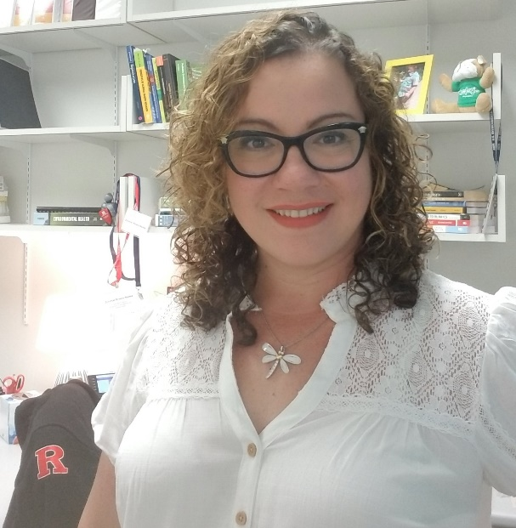
DR. ZORIMAR RIVERA-NÚÑEZ AWARDED BOTH A R21 AND AN ECHO GRANT FROM THE NIH!!!
Dr. Zorimar Rivera-Núñez, an Assistant Professor at the School of Public Health and Resident Scientist in the Environmental and Occupational Health Sciences Institute (EOHSI) was awarded her first R21 grant and an ECHO grant from the National Institutes of Health after participating in the National Research Mentoring Network-CIC Academic Network (NRMN-CAN) Grant Writing Group hosted at Rutgers University.

Rivera-Núñez’s research focuses on chemical exposures and its effects on early life and subsequent health. Most of her research addresses: (1) The effects of measurement error when characterizing environmental exposures, (2) The utility of biomarkers identifying windows of exposure and susceptibility, and (3) The impact of perinatal exposures on birth outcomes and children’s development.

When asked about what she studies, Rivera-Núñez explains, “The R21 grant studies an emergent chemical, zearalenone, which is a fungal-derived estrogenic chemical. There is little information of the impact of zearalenone in humans and studying something for the first time is always exciting. As part of the R21, we will study the impact of zearalenone in the human placenta and how well the baby grows. In the ECHO grant, we will also study the placenta and its role in restricting chemicals from reaching the baby. This is also an area of research where little in known in terms of environmental chemical exposures. The role of the placenta in both of these projects is novel and to be able to write these grants it required additional training on my part. Contributing new pieces to science is always exciting and inspirational.”
Rivera-Núñez learned about the NRMN-CAN grant writing group by way of Dr. Lauren Aleksunes, the Workforce Development Core Lead for the NJ Alliance for Clinical and Translational Sciences (NJ ACTS), and that is how she was invited to participate. Since joining the NRMN-CAN grant writing group, Rivera-Núñez states that, “NRMN has helped me in multiple areas of grantsmanship, it gave me clarity, simplicity, and proper order for my research pieces. Like learning that I have to have more than great ideas and this is something that most seasoned researchers know, but like many others in my early career it was quite frustrating. In academia, planning and conceptualizing one’s research program it is essential to build your scholarship and that is how these sessions helped me to narrow my focus on going beyond my usual approach to my research question. This ultimately translated my research program! Additionally, participating in this program will improve your reviewer’s skills by reading others research and listening to senior reviewers. Both Dr. Aleksunes and Dr. Suzie Chen provide you with writing edits and comments and that is very useful.”
Through conversation with Rivera-Núñez about this recent accomplishment, we asked, if someone called you and asked, “Why should I become involved with NRMN?” Rivera-Nunez’s response – “To improve your chances of being funded, to learn from senior reviewer’s and well-funded individuals, to meet other early career scientists and how they navigate academia. These sessions will narrow your focus with picking mentors that will truly be available to dedicate time to you and it will help you use the resources around you. By letting others read your proposals you will be trained to take criticism because this is a humbling process which will help to make you and your work better.”
After being awarded both grants, we were interested in learning more about what’s next for Dr. Rivera-Núñez. She was excited to share, “My hope is to go for my first R01!”
The NRMN-CAN Grant Writing Group is supported by NJ ACTS, the School of Graduate Studies, Ernest Mario School of Pharmacy, NIEHS Center for Environmental Exposures and Disease, and the Office of Research and Economic Development. For more information about NRMN-CAN, email aleksunes@eohsi.rutgers.edu or suziec@pharmacy.rutgers.edu.
Prepared by Yasheca Ebanks, MS, Project Manager, NJ Alliance for Clinical and Translational Sciences, Workforce Development Core

