Dr. Christoph Buettner

 cb1116@rutgers.edu

**Date and Time**

Monday August 29, 2022

1 PM

**Location: ZOOM**

<https://rutgers.zoom.us/j/91359444726?pwd=ekJWeDljdUc4eXljRXpuWEJMNWJUUT09>

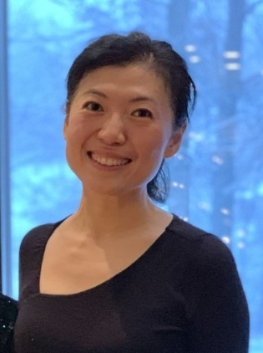

**Department of Medicine Faculty Candidate Seminar**

**Topic:**

Single cell multi-omics analysis of β cell heterogeneity and differentiation

**YAN, LI, PhD**

**Associate Professor Genetics and Genome Sciences Case Western Reserve University**

Hosted by Department of Medicine