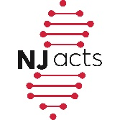
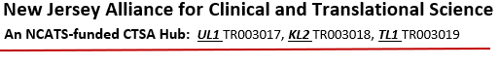

NJ ACTS Team Science Core
Presents

Kate Sasser, PhD
Senior Vice President
Head of Translational Research
Genmab Inc.
Plainsboro, New Jersey

Second Event of Teamwork Seminar Series:
“Secrets of Successful Teamwork:
What Can Academia Learn from Non-Academia?”

Monday, June 21, 2021
2:30 – 3:30 PM

Register in advance for this zoom meeting:
https://rutgers.zoom.us/meeting/register/tJArfuqurDIrGdC17htqVlIc4R_TaVLiqmi5
After registering, you will receive a confirmation email containing information about joining the meeting.

For further information, contact: Kristi Parker parkerkn@cinj.rutgers.edu

