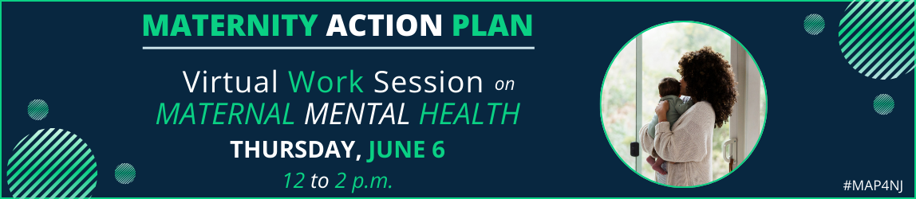

Please join the Quality Institute for this virtual work session focusing on maternal mental health information and resources beneficial to your community, clients or patients, on Thursday, June 6, 2024, from 12-2:00 p.m.
The session will feature Jaime Angelini, MA, DRCC, AMTP, Statewide Director of Suicide Prevention, Crisis Response, and Special Projects, Mental Health Association in NJ (MHANJ), Carolyn Flynn, LPC, CD, IMH-E®, Director, Infant and Early Childhood Relational Health, The Center for Great Expectations and Armonie Pierre-Jacques, MPH, Program Officer, New Jersey Health Care Quality Institute.
Regis
Register Now

