presents

RESOURCES FOR RESEARCHERS THROUGH THE CTSA
TRIAL INNOVATION NETWORK

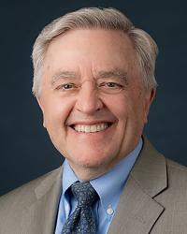
DANIEL FORD, MD, MPH
Director, Johns Hopkins Institute for Clinical and Translational Research
David M Levine Professor of Medicine
Senior Associate Dean for Clinical and Translational Research
Johns Hopkins School of Medicine


DIXIE THOMPSON, BSN, RN
Director of Research & Science
Utah Clinical & Translational Science Institute (CTSI)

12:00 pm – 1:30 pm
Thursday, December 19, 2024
Virtual
Join Zoom Meeting

Hosted by
Reynold A. Panettieri, Jr., MD
Vice Chancellor for Translational Medicine and Science
Director, Rutgers Institute for Translational Medicine and Science
[Contact Info: Nancy Reilly, reillyna@rbhs.rutgers.edu]

